



INTEGRATED OFFICE APPLICATIONS
(215)
NATIONAL 2021

Production:
Job 1: Performance Review Form (130 points)

Job 2: Content Controls ( 55 points)

Job 3: Spreadsheet (175 points)

Job 4: Link Performance Review and Results (170 points)

TOTAL POINTS (530 points)

Test Time: 90 minutes

GENERAL GUIDELINES:
Failure to adhere to any of the following rules will result in disqualification:
- Contestant must hand in this test booklet and all printouts if any. Failure to do so will result in disqualification.
- No equipment, supplies, or materials other than those specified for this event are allowed in the testing area. No previous BPA tests and/or sample tests (handwritten, photocopied, or keyed) are allowed in the testing area.
- Electronic devices will be monitored according to ACT standards.

EXAM GUIDELINES:
- Ensure this test booklet contains Jobs 1-4
- Key all jobs according to the instructions given.
- Correct any and all formatting, spelling or grammar errors. Use the formatting guide in the Style & Reference Manual.
- Your name or initials should not appear on any work you submit. Use your contestant number in any occasion you would normally key your reference initials.
- In the lower right hand corner of ALL work submitted (unless otherwise specified) key your contestant number and job number.
- If you complete the event before the end of the time allotted, notify the proctor. Time could be considered a factor in determining a winner when there is a tie score.
- Place your scoring sheet on top of your Jobs. Jobs should be in numerical order.

PRODUCTION STANDARDS
0 Errors | 100 Points
1 Error | 90 Points
2 Errors | 70 Points
3 Errors | 50 Points
4+ Errors | 0 Points

Job 1 – Performance Review Form | Possible Points | Points Awarded
Production Standards  0 errors - 100 points, 1 error - 90 points, 2 errors - 70 points,  3 errors – 50 points, 4 or more errors – 0 points | 100
Cell formatted to 0.2” tall and center aligned vertically | 10
Creativity (eye-catching and easy to read) | 10
Constant # and job # in right footer | 10
Total | 130
Job 2- Content Controls | Possible Points | Points Awarded
Employee Name – Rich Text Control Added | 5
Department – Drop-Down List Control Added | 5
Review Period – Date Control Added | 5
Employee – Text Form Control Added | 5
Job Title – Rich Text Control Added | 5
Date – Date Control Added | 5
Manager – Drop-Down List Control Added | 5
To – Date Control Added | 5
Supervisor Comments – Rich Text Control Added | 5
Constant # and job # in right footer | 10
Total | 55

Job 3 – Spreadsheet | Possible Points | Points Awarded
Production Standards  0 errors - 100 points, 1 error - 90 points, 2 errors - 70 points,  3 errors – 50 points, 4 or more errors – 0 points | 100
Inserted 3D Clustered Column chart for Average Rating | 10
Printed Justin, Melissa, and Larsen’s worksheets – 5 points for each printout | 15
Column and Row Headings showed | 10
Worksheets landscaped and fit to one page | 10
Printed Larsen Smith worksheet in formula view | 10
Correct formula used to calculate average rating | 10
Constant # and job # in right footer and sheet tab name in right footer (all or nothing and must be on all worksheets) | 10
Total | 175
Job 4 - Link Performance Review and Results | Possible Points | Points Awarded
Production Standards  0 errors - 100 points, 1 error - 90 points, 2 errors - 70 points,  3 errors – 50 points, 4 or more errors – 0 points | 100
All information is visible | 10
Corrected identified department manager | 10
Link Melissa’s rating information from supervisor and peers | 10
Link Melissa’s rating summary | 10
Imbedded Melissa’s rating chart | 10
Printed Melissa’s performance review so it fits on one page | 10
Constant # and job # in right footer | 10
Total | 170
TOTAL | 530

Job 1
Digital Solutions

Performance Review

Employee Information
Employee Name |  | Date
Job Title |  | Employee ID
Department |  | Manager
Review Period |  | To
Rating
Rating Summary
Rating Chart
Written Evaluation
Supervisor Comments

Notes to Grader:
- Design may be different
- Production standards (correct words)
- 0 errors - 100 points, 1 error - 90 points, 2 errors - 70 points, 3 errors – 50 points, 4 or more errors – 0 points
- Cell formatted to 0.2” tall and center aligned vertically – 10 points
- Creative (eye-catching and easy to read) – 10 points
- Contestant ID and Job # should be in right footer – 10 points

Job 2 – Content Controls
Digital Solutions

Performance Review

Employee Information
Employee Name | Click here to enter text. | Date | Click here to enter a date.
Job Title | Click here to enter text. | Employee ID
Department | Choose an item. | Manager | Choose an item.
Review Period | Click here to enter a date. | To | Click here to enter a date.
Rating
Rating Summary
Rating Chart
Written Evaluation
Supervisor Comments | Click here to enter text.

Note to grader:
- Employee Name – Rich Text Control Added – 5 points
- Department – Drop-Down List Control Added – 5 points
- Review Period – Date Control Added – 5 points
- Employee – Text Form Control Added – 5 points
- Job Title – Rich Text Control Added – 5 points
- Date – Date Control Added – 5 points
- Manager – Drop-Down List Control Added – 5 points
- To – Date Control Added – 5 points
- Supervisor Comments – Rich Text Control Added – 5 points
- Constant # and job # in right footer – 10 points

Job 3 – Spreadsheet
Justin Wilson printout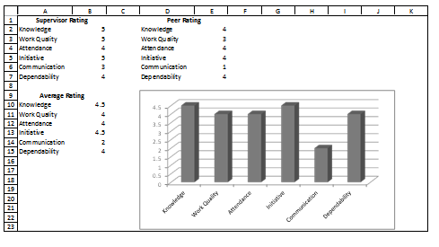
Melissa Kaiser printout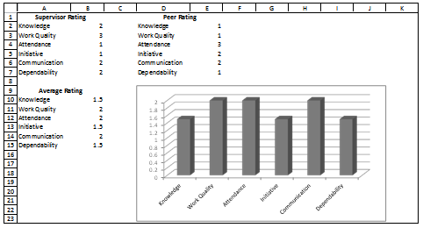
Notes to Grader:
- Production Standards
  - 0 errors - 100 points, 1 error - 90 points, 2 errors - 70 points, 3 errors – 50 points, 4 or more errors – 0 points
- Inserted 3D Clustered Column chart for Average Rating – 10 points
  - No title is needed for the chart
- Printed Justin, Melissa, and Larsen’s worksheets – 5 points for each printout – 15 points total
- Column and Row Headings showed – 10 points
- Worksheets landscaped and fit to one page – 10 points
- Printed Larsen Smith worksheet in formula view – 10 points
- Correct formula used to calculate average rating – 10 points
- Constant # and job # in right footer and sheet tab name in right footer (all or nothing and must be on all worksheets) – 10 points

Larsen Smith printout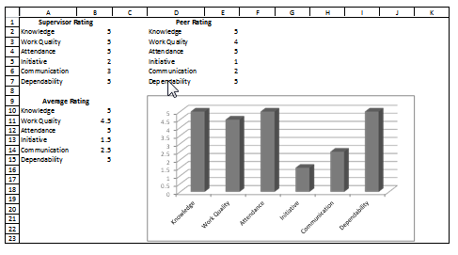
Formula View for Larsen Smith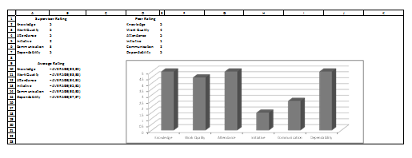
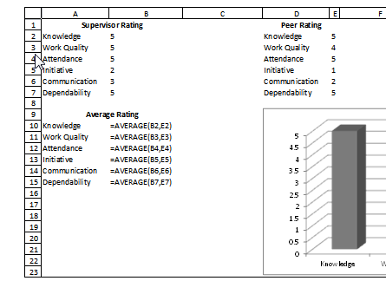
Note to Grader:
Closer look a formula for Average Rating. Keep in mind that there are multiple was to get this answer. As long as they use a formula it is fine.
Job 4 – Link Performance Review and Results
Digital Solutions

Performance Review

Employee Information
Employee Name | Melissa Kaiser | Date | 4/4/2021
Job Title | Sales Agent | Employee ID | 9874
Department | Information Technology | Manager | Tom Carlson
Review Period | 3/20/2021 | To | 3/24/2021
Rating
Rating Summary
Rating Chart
Written Evaluation
Supervisor Comments | Melissa needs to develop a more conventional work ethic.

Notes to Grader:
- Production Standards
  - 0 errors - 100 points, 1 error - 90 points, 2 errors - 70 points, 3 errors – 50 points, 4 or more errors – 0 points
- All information is visible – 10 points
- Corrected identified department manager – 10 points
- Link Melissa’s rating information from supervisor and peers – 10 points
- Link Melissa’s rating summary – 10 points
- Imbedded Melissa’s rating chart – 10 points
- Printed Melissa’s performance review so it fits on one page – 10 points
- Constant # and job # in right footer – 10 points

